In Linux, a service (often called a daemon process) is a program that runs continuously in the background to provide specific functionality to the operating system or other applications, without direct user interaction
They perform crucial tasks like managing network connections (sshd for remote logins), serving web content (httpd or apache2), and scheduling automated tasks (crond).
What is systemctl?
systemctl is the primary command-line tool for managing the systemd service manager in Linux, acting as the main interface to start, stop, restart, enable, or disable services, and to check system status. It is used to manage system state, control boot behavior, and inspect unit configurations.
Core systemctl Commands:
- Service Management: sudo systemctl [start|stop|restart|reload|status] service_name.
- Boot Control: sudo systemctl [enable|disable] service_name (configure automatic start at boot).
- System State: systemctl status (view all services), systemctl --failed (check failed units).
- Power Management:
sudo systemctl [poweroff|reboot|suspend]
What is systemd?
- It is an “init system”
- Init system is the most important process running on your server (PID 1)
- It manages all services that run in the background (start, stop, reload)
- You can view this by running htop(a program to see what’s running behind the scenes).
- It allows following process management features and more:
- Ability to enable the administrator
- Schedule tasks
- To only tasks when specific criteria is met
- To ensure a process is always running
- To configure logging
- How DNS is resolved
Why systemd?
- Faster boot-up times, since daemons(background processes) start in parallel
- You can configure daemons to automatically restart upon a daemon crash
- Better security: “auditd” daemon can’t be stopped or restarted by any user, including the root user. So no hacker would be able to cover their tracks by shutting down the auditing system, even if they were to gain root privileges.
- Every process runs in its own ‘cgroup’ by default. ‘cgroup’ makes it simpler to control resource(CPU,RAM) usage for processes and also provides better process separation which makes it difficult for hackers to exploit the system.
- Same commands for enabling and disabling daemons across different families (Debian, Red Hat, etc)
Systemd concepts you should know!
Units:
- Units in systemd are resources that it’s able to manage. Type of units: Services, timers, mounts, automounts, etc
You can initialize any linux based VM. I will initialize an Ubuntu VM and login to the VM
- Install apache2 (HTTP server)
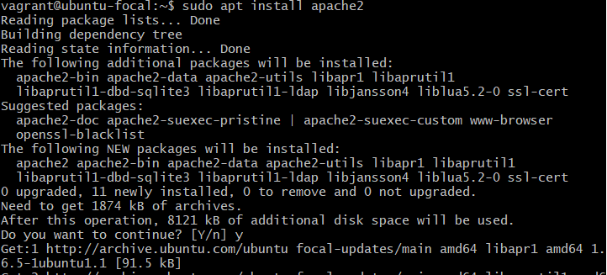
- Check status of the service
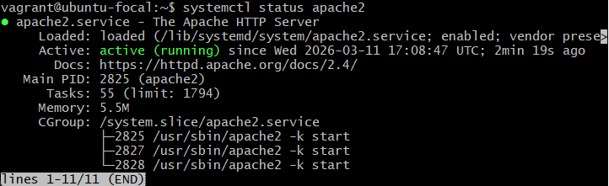
- You can use the following command if the status is “inactive”
systemctl enable apache2
- Stop the service and check status
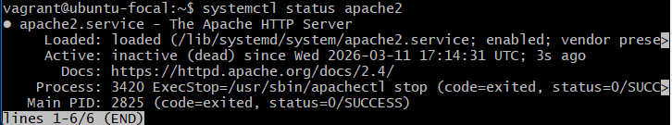
- If you have made any changes to any configuration file, then your service might need a restart
sudo systemctl restart apache2

Systemctl and Apache Tomcat 10
There are some services for which you don’t get systemctl by default. Apache tomcat is one of them. Apache tomcat is a Java servlet container i.e. it serves java-based web apps. (Different from typical apache server which serves html)
Experiment to write our own systemd conf file for Tomcat service:
First we will see how we can install and run the tomcat service without systemctl
- Bring up CentOS VM
- Login to the VM and switch to root user
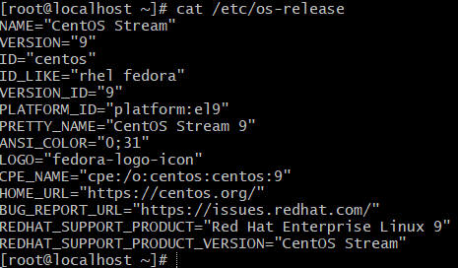
- Install httpd service
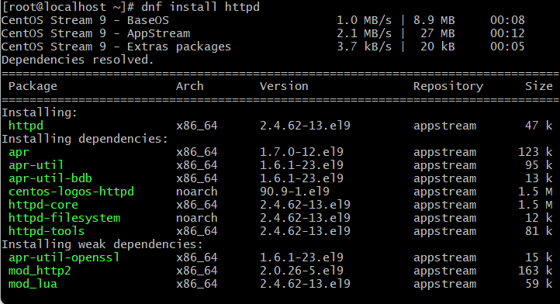
Httpd service can be directly managed by systemctl
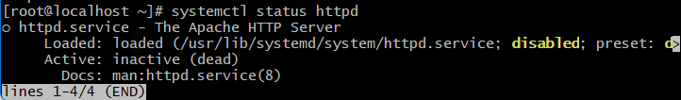
- You can view the httpd.service for systemctl
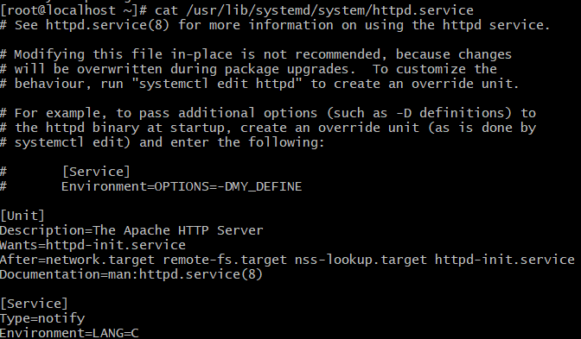
- The config file for httpd
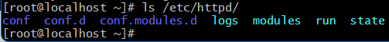
- Logs for httpd can be found in - ls /var/log/httpd/
- Get tarball for Apache Tomcat 10
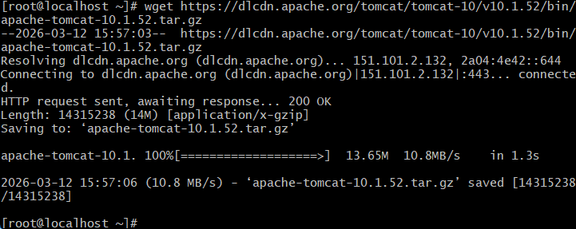
- Extract the tarball
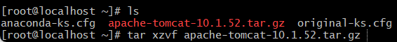
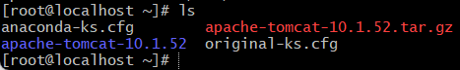
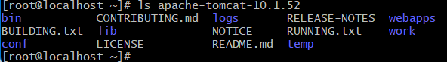
- Install java as it is a dependency
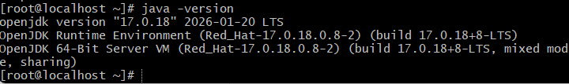
- The apache tomcat startup script will be located in the extracted folder inside bin/
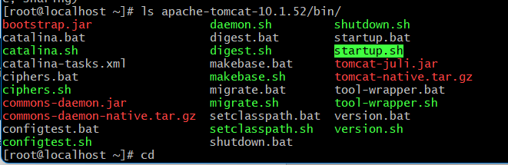
- Run this shell script (.sh) to start the service
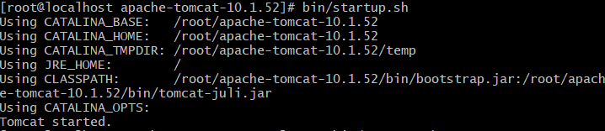
- You can use the “ps -ef” command to check the status of active processes on a system, as well as display technical information about the processes
- Check tomcat process running
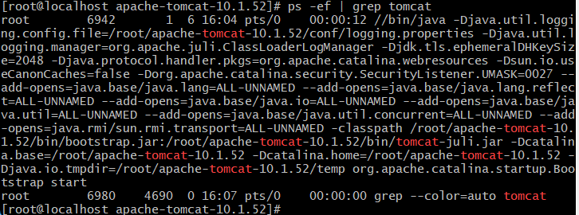
- Ip address of the VM:8080 in the URL will take you to default Apache Tomcat webpage
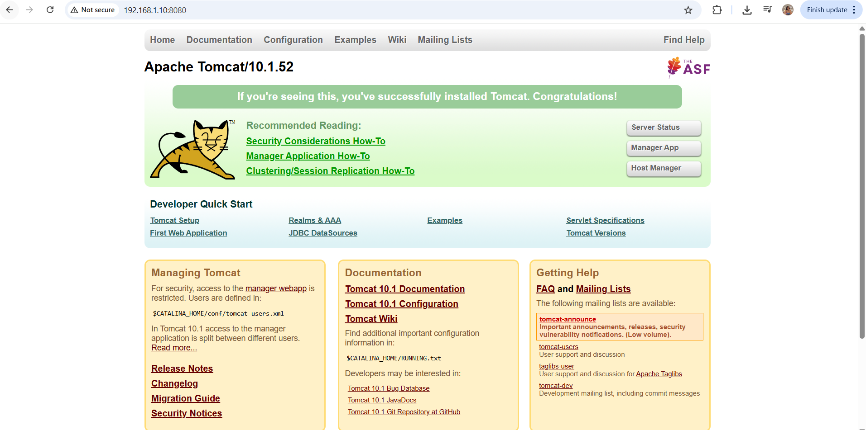
Problem with this approach:
- During boot time, the apache tomcat service will be disabled by default. You can’t set it to be enabled without systemctl
- Different start and stop scripts for different linux families
- Integration with other DevOps tools like Ansible is difficult without systemctl. Ansible contacts systemctl for managing any service
Creating systemd file for Apache Tomcat
- Any service (including tomcat) should be run as non-root user.
- Therefore, you must have a user for each service
- Create user for tomcat and a home directory (for secure, isolated storage of application-specific configuration files, runtime data, cache, and encryption keys, rather than cluttering system-wide directories) with no shell
- Copy all the content of downloaded apache-tomcat folder to home-dir of “tomcat” user
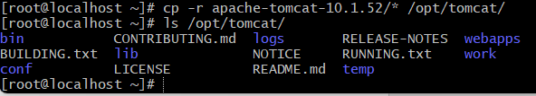
- Change ownership of home-dir to “tomcat” user
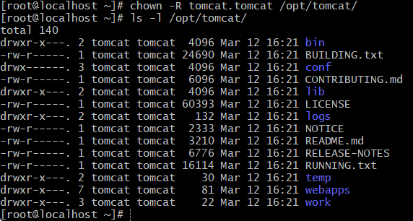
- Create configuration file for tomcat in /etc/systemd/system/
- # cat /etc/systemd/system/tomcat.service
- [Unit]
- Description=Tomcat
- After=network.target

- [Service]
- Type=forking
- User=tomcat
- Group=tomcat

- WorkingDirectory=/opt/tomcat

- Environment=JAVA_HOME=/usr/lib/jvm/jre/

- Environment=CATALINA_BASE=/opt/tomcat
- Environment=CATALINA_HOME=/opt/tomcat

- ExecStart=/opt/tomcat/bin/startup.sh
- ExecStop=/opt/tomcat/bin/shutdown.sh

- [Install]
- WantedBy=multi-user.target
3 directives. –
- Unit(Specify global info like description and dependency)- After=network.target is a dependency which means after all the network services get started
- Service- Mention user, group, working directory, environment variables for tomcat service(not for systemd) and executable files for starting and stopping. Type=forking means tomcat service can start child processes
- Install- WantedBy=multi-user_target means complete OS tsratup except the GUI. It is non-GUI mode startup
- After making change in the /etc/systemd/ you need to reload the daemon
- Start the tomcat service and check the status
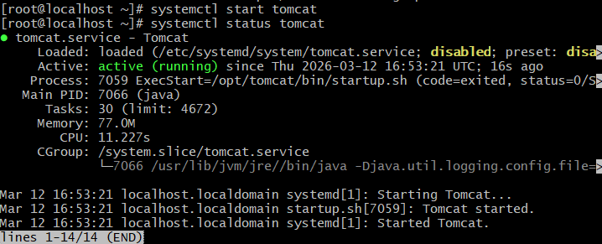
- If you enable the tomcat service, then it will be up even after VM reboot

